Chart Management Functional Requirements

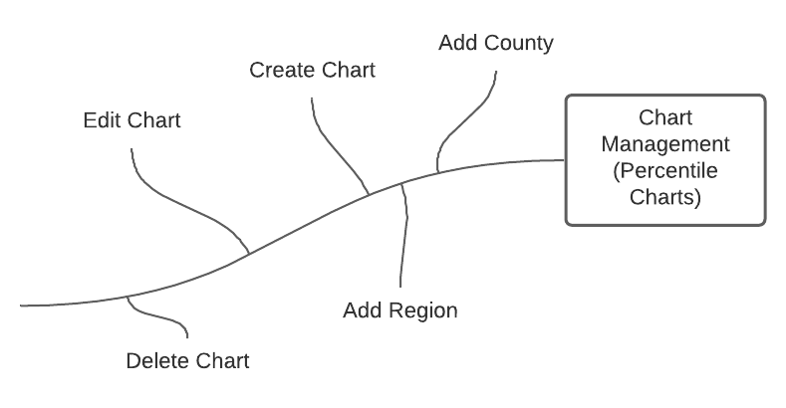

# Functional Requirements

1. The system will allow Admins and Cartographers to create new charts.
2. The system will allow chart creators to edit the chart they personal made.
3. Admins will be allowed by the system to edit everyone’s charts.
4. The chart management system will allow users to only add one region.
5. The chart management system will not allow user to add counties if a region is already added.
6. The chart management system will not allow user to add a region if a county is already added.
7. The chart management system will allow users to select a specific CSV year.
8. The chart management system will allow user to select a specific health indicator form the selected CSV year.
9. The CPH system will allow chart creators to delete a chart.
10. The chart system shall handle undefined counties in specific CSV years that are defined in user created regions.